Experiment – 1
Program:
import cv2
# Read image
img = cv2.imread("image.jpg")
# Convert to grayscale
gray = cv2.cvtColor(img, cv2.COLOR_BGR2GRAY)
# Display images
cv2.imshow("Original Image", img)
cv2.imshow("Grayscale Image", gray)
cv2.waitKey(0)
cv2.destroyAllWindows()
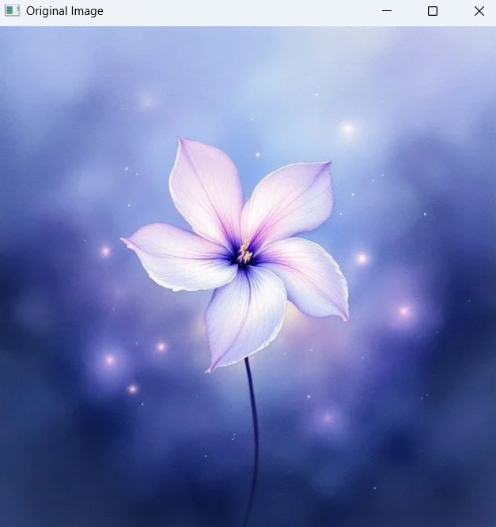
Input:

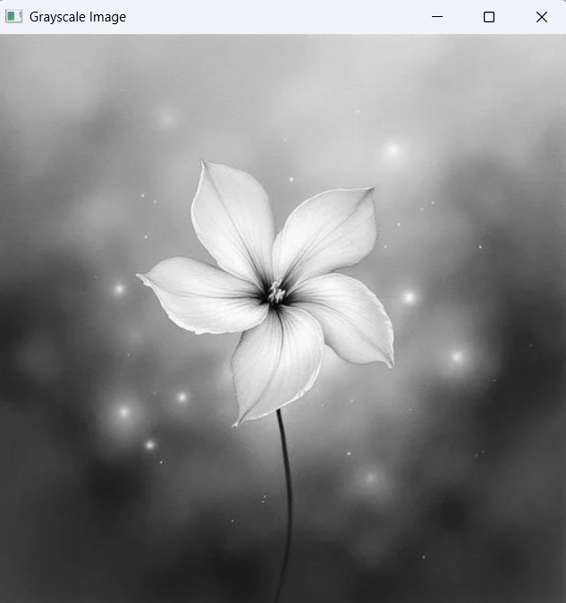
Output:

